Sustainable Asset Management Strategy (2024 -2029)
The strategy introduces four strategic principles as its core: -
- Remain customer focused,
- Optimise data intelligence,
- Robust investment needs, and
- Effective and meaningful monitoring and reporting.

Through the application of the strategic principles, this Strategy clarifies our approach to managing and maintaining our property assets, with the aim of embedding sustainability and delivering value for money for our customers, colleagues, and stakeholders. It provides a strategic framework to enable effective management of our housing stock and support the delivery of our Corporate Strategy objectives. It also helps ensure that we meet our legal and regulatory obligations as a community landlord.
The objectives of this strategy are to deliver the specific outputs highlighted below, which ultimately lead to the outcome of Bron Afon becoming more prepared, evidence-based, effective & efficient, innovative, and proactive in our approach to asset management.

The effectiveness of this strategy will be demonstrated in the progress of our actions to achieve the above objectives.
Our Baseline
We are the largest private landowner in Torfaen. Almost 18,000 people live in our properties, with around ??% under the age of 17. Our assets have a major role to play building prosperity of our customers of today and the future.
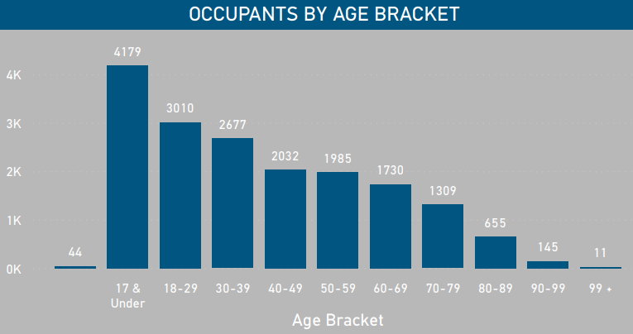
Based on our current data, Table 1 shows the count of property age by type and Figure 1 shows the percentage of the stock by age and type. 6,607 (81% of the housing stock) was built between 1950 and 1982. There are 2,828 (35%) flats, 2,164 (27%) mid terrace, 1,338 (17%) end terrace and 1,477 (18%) semi-detached. There are a small number of detached dwellings, 55 (1%), and 181 (2%) maisonettes.
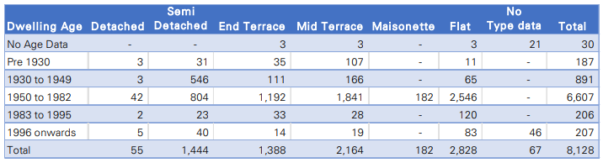
Table1 – Number of properties per age per architype
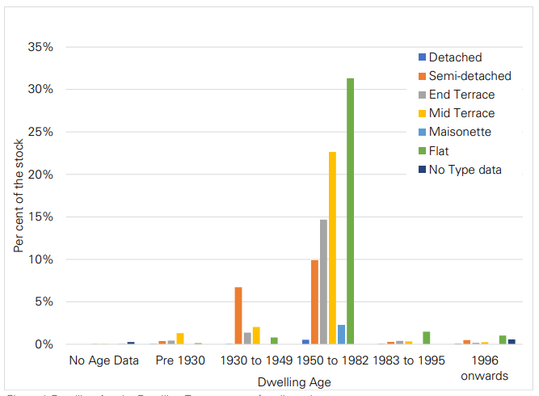
Figure1 – Proportion of properties per age per architype

Our assessment of stock data against the WHQS23 decarbonation elements shows the majority of our properties as having average SAP and Environmental Rating band C and D, as per Table 2 and 3 and Figure 2 and 3.
Using our existing modelled decarbonisation retrofit measure with specific assumptions set for the assessment, our data suggests that 97% of the stock can achieve the SAP 75 target and 51% can achieve a SAP of 92.
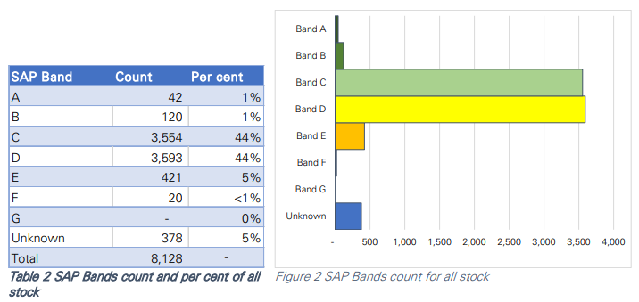

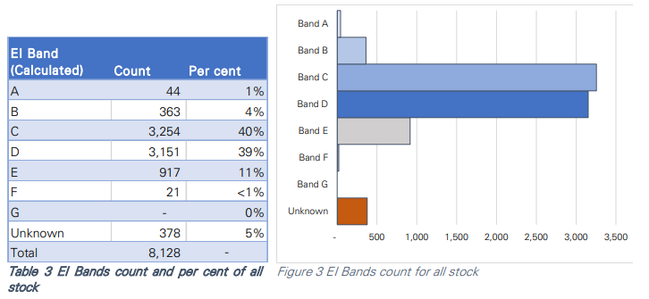
Based on the stock data, we have significant outstanding component replacement requiring capital investment that is considered to be financially unaffordable. Validation of data will be required to improve our level of confidence. The following graphs show investment needs (capital) over the period 5 years), based in our current stock condition data. The profile of actual investment will be subject to the implementation of this Asset Strategy, which will include routine data quality improvement and analysis and incorporation of WHQS23 requirements.

The Strategic Principles
Strategic Principle 1: Remain Customer Focused
Customer engagement and involvement will be a critical element of the implementation of this strategy, and its associated workstream and actions. The approach to customer engagement and involvement will be in line with the commitment and model set out in our Customer Voice Strategy.
This strategic principle will also help ensure that Bron Afon’s approach to developing our investment plan and delivery programme for WHQS 2023 meets the expectation Welsh Government set out in the Standard.
In remaining customer focused, we will also adhere to our Equality, Diversity and Inclusion Policy, to ensure that the management of our assets, so far as practical, enables us to provide services that are tailored to the needs of our customers.
Strategic Principle 2: Optimise Data Intelligence
Our approach to sustainable asset management will be informed by data and evidence, which will be subject to continuous improvements in the collation, analysis, management, and utilisation of our ‘intelligence’ that is all our data and information. This will in turn improve our strategic decision-making to ensure that our homes remain fit for purpose long into the future.
Improving the quality of our data and our capability to utilise it will be a key factor to enable us to better target our investment to meet the requirements of Welsh Housing Quality Standard 2023 and ensure the long-term sustainability of our homes.
Strategic Principle 3: Robust Investment Needs
Setting robust investment needs will help establish a clear direction for the business on what we need to focus on in formulating our investment plan and the management of our assets.
Whilst the primary driver and determinant of our investment in our existing homes in the coming years will be the delivery of WHQS 2023, we will apply a long-term view to incorporate the following factors in shaping our investment needs.
- Landlord compliance and building safety
- Meeting customer expectations
- Climate change and wider environmental sustainability
- Social value and supporting local supply chains
- Emerging technology
- Our vision for DLO.

Strategic Principle 4: Effective and Meaningful Monitoring and Reporting
Effective and meaningful monitoring and reporting will enable us to continuously reflect and improve.

The Strategy itself will also be subject to monitoring, through the delivery of the strategic delivery plan, which aims to deliver the SMART objectives of the strategy.

We will continuously review our asset performance and update our plans. Our approach is included in the diagram below and is in line with the key principles of ISO55001, which this strategy aspires to achieve.
